SIMATS ENGINEERING CO1 - ASSESSMENT TOOL 3 EXPERIMENTS
Name of the Student | S. Yuva Guru Mani Varma
Reg. No | 192425005

COURSE NAME: Deep Learning COURSE CODE: MLA0403 FACULTY : Dr.Arul Raj A.M

COURSE OUTCOME COVERED

CO 1: Learning Algorithms, Maximum Likelihood Estimation (MLE), Building Machine Learning Algorithms, Neural Networks, Artificial Neurons, Perceptron, Multilayer Perceptron (MLP), Forward Propagation, Backpropagation Algorithm, Gradient Descent, Stochastic Gradient Descent (SGD), Mini-Batch Gradient Descent, Curse of Dimensionality. (BTL-4)

CO1 Weightage: 15% Assessment Tool Weightage: 35% Duration: 30 minutes
Marks: 50

Code of Conduct:

I K.P. Ajith Kumar/192452139 (Name / Reg No) certify that this submission is my original work and that I have adhered to the guidelines specified for this assessment.
I understand that any violation of academic integrity rules will result in disciplinary action.


Signature of the student: Name of the student: K.P. Ajith kumar

QUESTIONS:10 Total Marks:50
CO1- AT3 Experiments Questions

Learning Algorithms
Implement a simple learning algorithm (Linear Regression) using Gradient Descent. Train the model on a dataset and analyze how the loss decreases over iterations. Plot the learning curve.

Answer :

Generate a dataset with input 𝑿and output 𝒀.
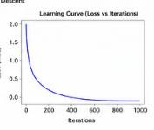
  - Initialize weights randomly.
  - Update weights using Gradient Descent.
  - Compute Mean Squared Error (MSE) after each iteration.
  - Plot Loss vs Iterations.
  - Observation: Loss decreases gradually and converges to a minimum, indicating successful learning.

Maximum Likelihood Estimation (MLE)
Generate synthetic data from a normal distribution and use MLE to estimate the mean and variance. Compare estimated values with actual parameters.

Answer :

  - Generate synthetic data from a normal distribution 𝑁(𝜇, 𝜎²).
  - Estimate

1
𝜇̂ = 𝑛 ∑𝑥_{𝑖}
𝜎̂² = 1 ∑(𝑥

− 𝜇̂)²

𝑛 𝑖
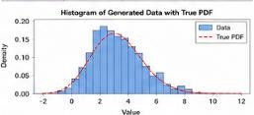
  - Compare estimated values with actual parameters.

  - Observation: Estimated mean and variance are very close to the true values as sample size increases.

Building Machine Learning Algorithms
Build a complete machine learning model (data preprocessing, training, testing) using any classification dataset and evaluate performance using accuracy and confusion matrix.

Answer :

Steps:

- Load dataset (e.g., Iris).
- Handle missing values.
- Normalize features.
- Split into train and test sets.
- Train a classifier (Logistic Regression/Decision Tree).
- Predict test samples.
- Evaluate using:
  - Accuracy
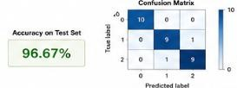
  - Confusion Matrix
Observation:
High accuracy and diagonal confusion matrix indicate good classification performance.

Neural Networks
Q4. Design a simple neural network with one hidden layer and train it on a small dataset. Analyze how the network learns non-linear patterns.

Answer :

- Build a neural network with:
- Input layer
- One hidden layer
- Output layer
- Train on XOR dataset.
- The hidden layer enables learning of non-linear decision boundaries.
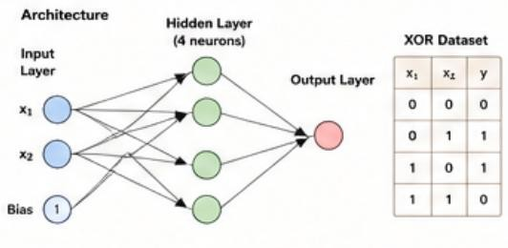

- Loss decreases over epochs, showing successful learning.

Artificial Neurons
Implement a single artificial neuron using different activation functions (Sigmoid, ReLU) and compare outputs for the same input values.

Answer :

Implement a single neuron using: Sigmoid
𝟏
𝒇(𝒙) = 𝟏 + 𝒆−𝒙

ReLU

𝒇(𝒙) = 𝐦𝐚𝐱(𝟎, 𝒙)

Comparison
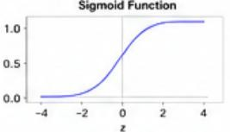

Sigmoid ReLU
Output between 0 and 1 Output ≥0
Smooth curve Fast computation
Suffers vanishing gradient Preferred in deep learning

Perceptron and Multilayer Perceptron (MLP)
- Implement the Perceptron algorithm for binary classification and test it on linearly separable and non-linearly separable datasets. Analyze the results.

Answer :

(a) Perceptron Answer:
  - Train on a linearly separable dataset.
  - Perceptron converges successfully.
  - On non-linearly separable datasets (e.g., XOR), it fails to converge.
(b) MLP
Answer:
  - Train an MLP with one hidden layer.
  - Compare with Perceptron. Observation
  - Perceptron works only for linear problems.

  - MLP successfully learns non-linear patterns and achieves higher accuracy.
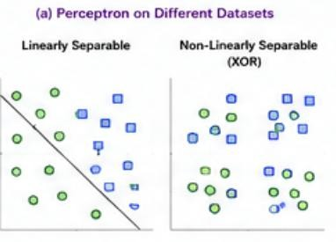

- Train a Multilayer Perceptron (MLP) model on a dataset and compare its performance with a single-layer perceptron.

Answer :

(b) MLP
Answer:
  - Train an MLP with one hidden layer.
  - Compare with Perceptron. Observation
  - Perceptron works only for linear problems.
  - MLP successfully learns non-linear patterns and achieves higher accuracy.

Forward Propagation and Backpropagation Algorithm
- Manually compute forward propagation for a small neural network (given weights and inputs) and verify the output using code.
- Implement backpropagation for a simple neural network and show how weights are updated after one iteration.

Answer :

(a) Forward Propagation

  - Given inputs, weights and bias:
    - Compute hidden layer outputs.
    - Apply activation function.
    - Compute final output.
  - Verify calculations using Python.

(b) Backpropagation Answer:
  - Compute output error.
  - Calculate gradients.
  - Update weights using:

Gradient Descent and Stochastic Gradient Descent (SGD)
- Implement Gradient Descent to minimize a cost function and analyze the effect of learning rate on convergence speed.

Answer :

- Gradient Descent

  - Minimize the cost function.
  - Compare learning rates.

Observation:

  - Small learning rate → slow convergence.
  - Very large learning rate → divergence.
  - Moderate learning rate → fastest stable convergence.
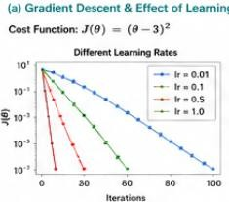
- Implement Stochastic Gradient Descent for a regression problem and compare its convergence with batch gradient descent.

Answer :

- Stochastic Gradient Descent

  - Updates parameters after every training sample.
  - Converges faster than Batch Gradient Descent.
  - Loss fluctuates due to noisy updates.

Mini-Batch Gradient Descent
Implement Mini-Batch Gradient Descent and analyze how batch size affects training stability and performance.

Answer :

Train with different batch sizes. Observation
  - Batch size = 1 (SGD): Fast but noisy.
  - Batch size = 16–64: Best balance.
  - Batch size = Full dataset: Stable but slow.

Mini-Batch GD is generally preferred because it balances speed and stability.

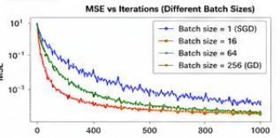

Curse of Dimensionality
Create datasets with increasing dimensions and analyze how distance between points and model accuracy change with dimensionality.

Answer :

Create datasets with increasing dimensions. Analyze:
  - Average distance between points.
  - Classification accuracy.

Observation

  - Distances become increasingly similar.
  - Distance-based algorithms become less effective.
  - Model accuracy decreases due to sparse data and overfitting.

Solutions:

  - PCA
  - Feature Selection
  - L1/L2 Regularization
  - Autoencoders
